Work Instructions

API

Group 11

Mihail Josan

Cristian Trifan

Blossom Anukposi

Stefan Cazacu

NHL Stenden University of Applied Science, January 17th, 2025

Table of Contents

1. Introduction 3

2. Install the necessary tools. 4

3. How to download the project 5

4. How to run the project 7

# Introduction

This document provides detailed work instructions for setting up and running the API Project as part of the coursework at NHL Stenden University of Applied Sciences. The instructions cover all the essential steps required to install the necessary tools, such as Visual Studio Code, Node.js, and relevant API testing tools, download the project files, and execute both the backend API and any associated frontend components of the project.

The instructions are structured to be clear and accessible, with step-by-step processes supported by visual aids, links to resources, and practical tips to address common issues. By following this guide, users will be able to set up the development environment and begin working on the API Project seamlessly.

# 2.Install the necessary tools.

* How to install Visual Studio Code:

* To install Visual Studio Code follow the YouTube link:

<https://www.youtube.com/watch?v=cu_ykIfBprI>

* Also, the link for VS Code:

<https://code.visualstudio.com/Download>

* How to install Node.js
* To install Node.js follow the YouTube link:

<https://www.youtube.com/watch?v=4FAtFwKVhn0>

* Also, the link for Node.js:

<https://nodejs.org/en/download>

For a better understanding, you can find in the picture below where you can press to download Node JS. Don’t forget to get the last LTS Version.

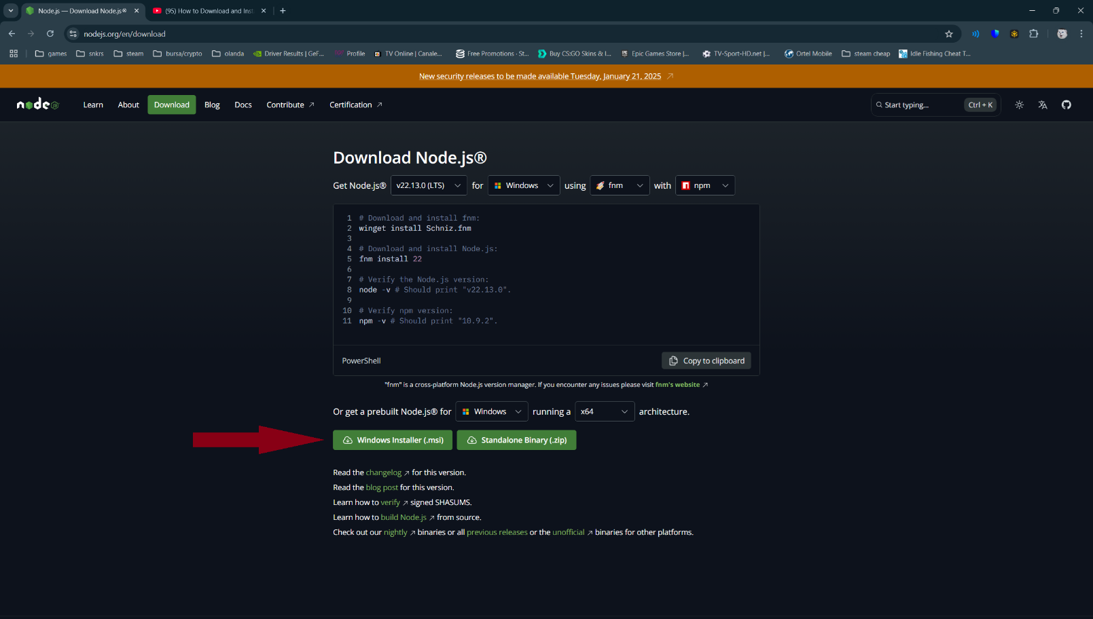

# 3.How to download the project

1. We access the link: <https://github.com/BlossomAnukposi/DataProcessing>

After we access the link this screen you should see:

Next step is to click on the green button that is named CODE, then you need to click on “Download ZIP”:

After that we go in the file explorer and in the folder where we downloaded our folder and press on the right click on your mouse and press on extract all:

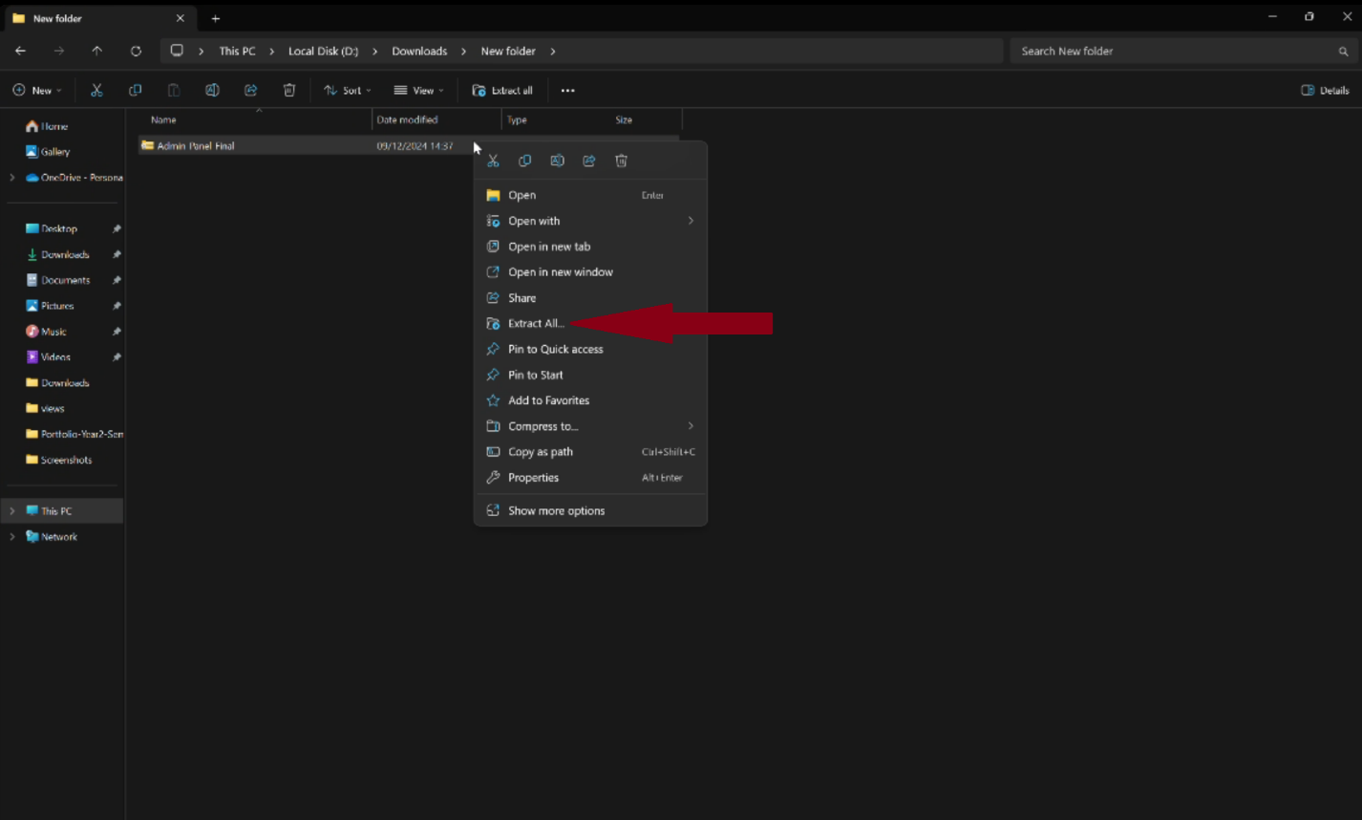

After you press extract all you will see this screen (look below) and press extract:

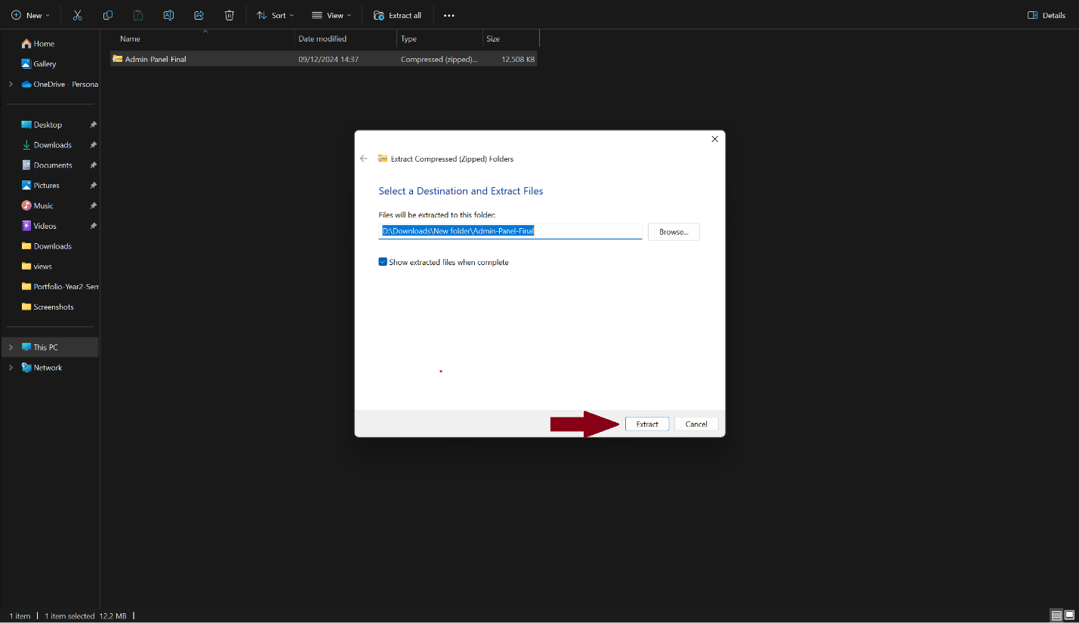

# 4.How to run the project

First open the VS Code, and then click on the Explorer that is marked with an arrow.

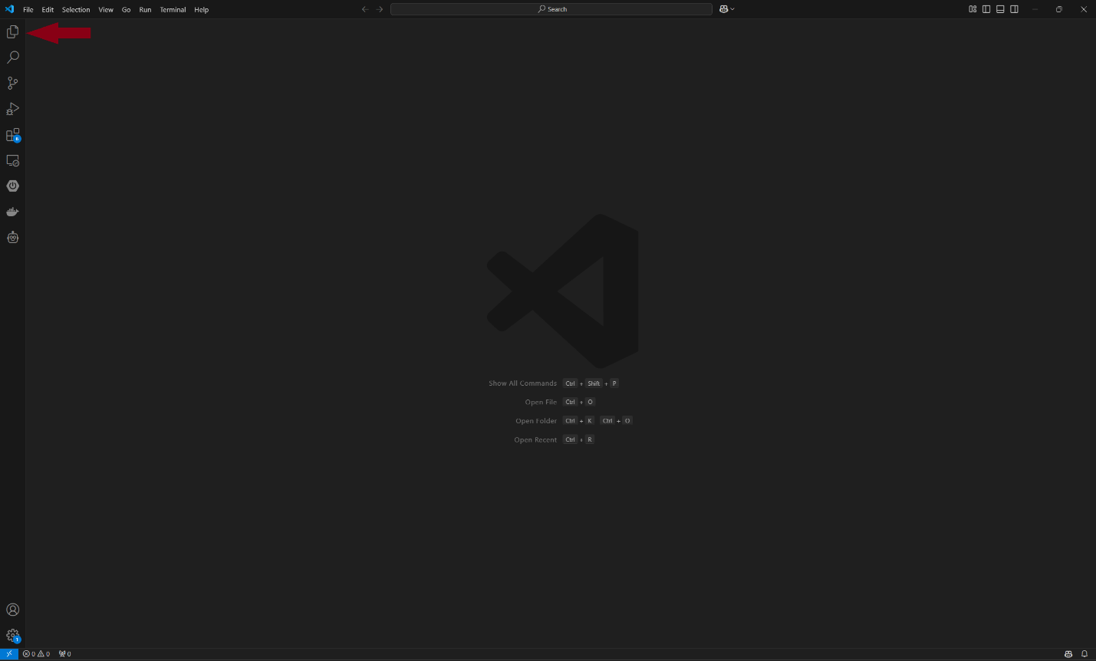

Then select Open folder:

Select the DataProcessing folder

After you selected the folder, press on the Terminal

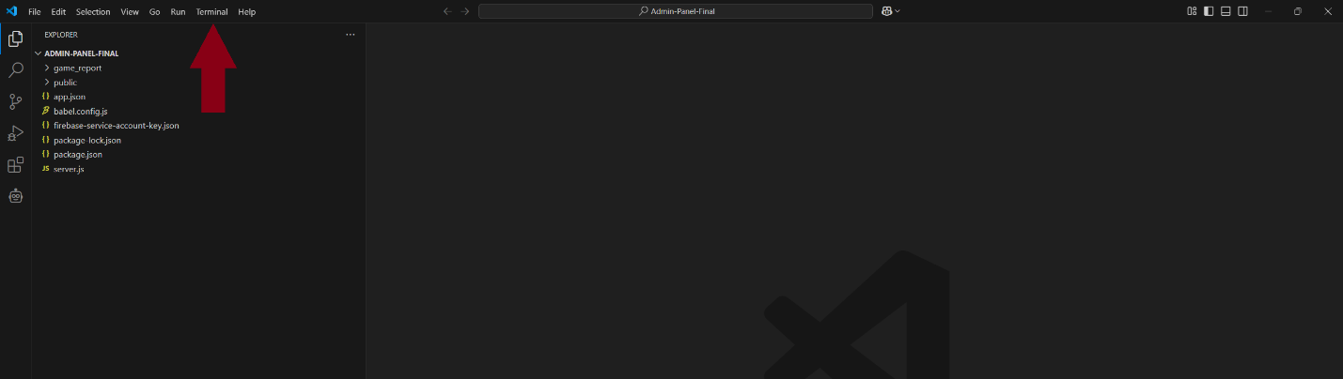

Then, press on the New Terminal

In the terminal, write “npm init -y”

After write in the terminal “npm install”



If you encounter errors similar to the photo, please write “npm install –legacy-peer-deps”

To run the project now write node server.js

To access the frontend, go into to DataProcessing folder and enter in com.nhlstenden folder

After that access the views folder

Last part is to create an account and press Sign up

Enjoy!